Name: Glia Mae Rio David
Course & Year: BSIT 3-A
Date: March 26, 2026

Activity 2: UML Diagram Design Project
Title: “Hulyanas Hill Information and Ordering System”

- SYSTEM DESCRIPTION

The Hulyanas Hill Information and Ordering System is a web-based application designed to simplify the ordering process for customers while helping administrators manage products and orders efficiently. The system allows users to register, log in, browse menu items, add or remove items from their cart, and complete transactions through a checkout process. It also provides features such as order tracking, viewing order details, and generating invoices.
On the administrative side, the system enables the admin to manage menu items by adding, updating, or deleting products. The admin can also view order details and monitor user information to ensure smooth operations. Overall, the system improves convenience, organization, and service efficiency for both customers and administrators.

- ACTORS / USERS
- User (Customer)
- Admin

- MAIN SYSTEM FUNCTIONS
User Functions
- Register an account
- Login account
- Manage personal information
- Change password
- Delete account
- View menu
- Add items to cart
- Remove items from cart
- Checkout orders
- View order details
- Track order status
- View invoice

Admin Functions
- Login
- Add item
- Update item
- Delete item
- View menu details
- View order details
- View user details

- UML DIAGRAM (USE CASE DIAGRAM)
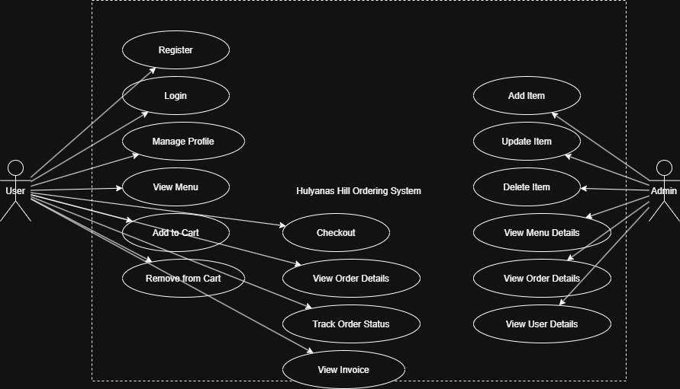
Tool Used (Draw.io)

